sudo apt update
2. sudo apt install apt-transport-https ca-certificates curl software-properties-common

Then add the GPG key for the official Docker repository to your system:
3.curl -fsSL https://download.docker.com/linux/ubuntu/gpg | sudo apt-key add -

Add the Docker repository to APT sources:
4.sudo add-apt-repository "deb [arch=amd64] https://download.docker.com/linux/ubuntu focal stable"

Make sure you are about to install from the Docker repo instead of the default Ubuntu repo:
5.apt-cache policy docker-ce

Finally, install Docker:
6.sudo apt install docker-ce

Docker should now be installed, the daemon started, and the process enabled to start on boot. Check that it’s running:
7.sudo systemctl status docker

you want to avoid typing sudo whenever you run the docker command, add your username to the docker group:
8.sudo usermod -aG docker ${USER}

or
sudo usermod -aG docker vaagdevi

To apply the new group membership, log out of the server and back in, or type the following:
9.su - ${USER}
docker version checking and pulling ubuntu image
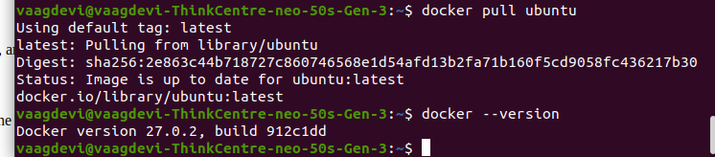
docker -–help
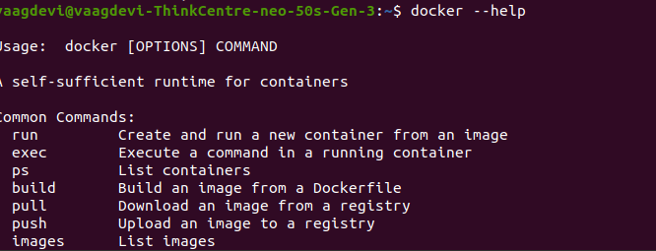

Confirm that your user is now added to the docker group by typing:

docker info
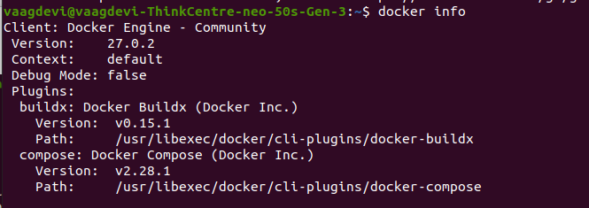
$ docker run hello-world
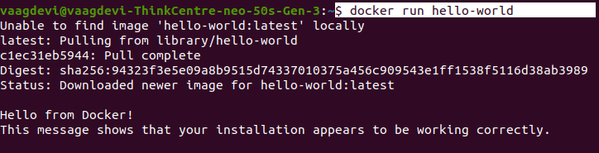
docker search ubuntu

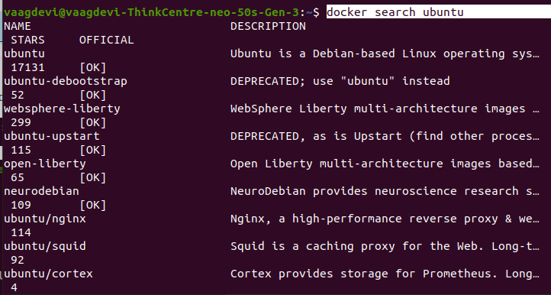
docker pull ubuntu
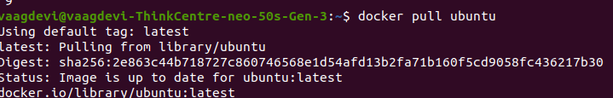
docker images

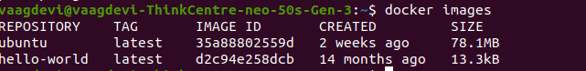
l
Containers can be much more useful than that, and they can be interactive. After all, they are similar to virtual machines, only more resource-friendly.
As an example, let’s run a container using the latest image of Ubuntu. The combination of the -i and -t switches gives you interactive shell access into the container:
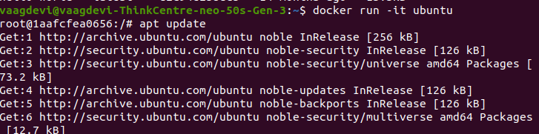

Output

root@d9b100f2f636:/#apt update
apt install nodejs
node -v
exit
list of processes running
docker ps

To view all containers — active and inactive, run docker ps with the -a switch:
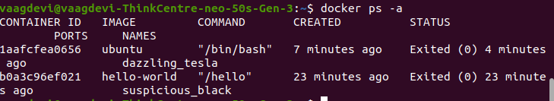

To view the latest container you created, pass it the -l switch:
h

